JAVA

Videos: https://www.youtube.com/watch?v=HuYs2Vp3GtM&list=PL8viY8757Sl-ApSVj1Et3WpWG1wdeFBXd
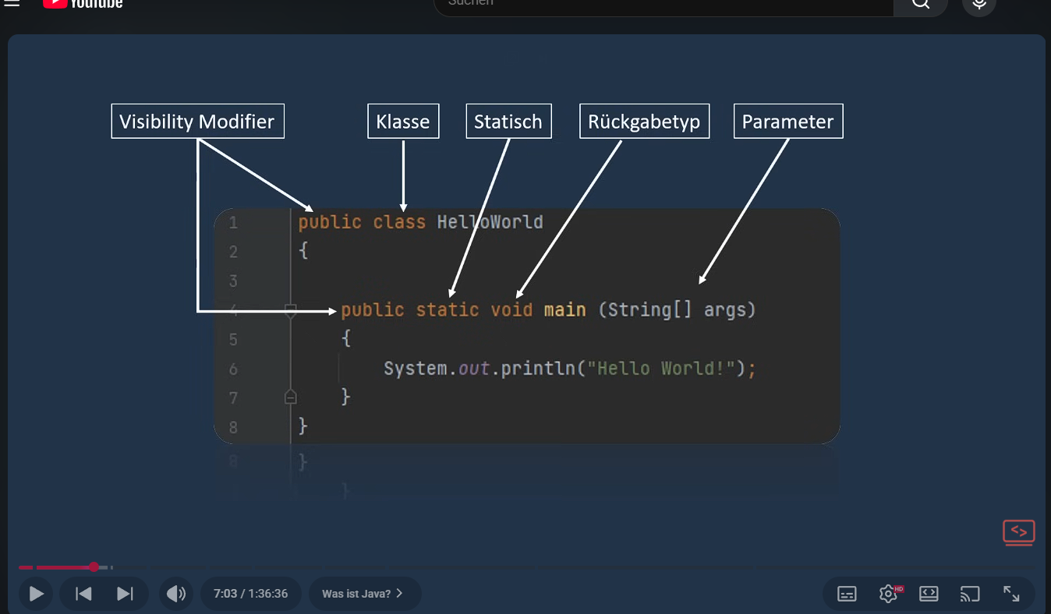

Startcode
JAVA Header
public class Main {

public static void main(String[] args) {
pintcode
}
}

Start bat code

echo off
java -jar Exaroton_money_calculator.jar
pause
addiert

int sum = number + number2;

save right or false
boolean bool = false;
boolean bool = right;

Exclusive or make the code if something ist right and the other is true

Boolean jan_gewonnen = true;
Boolean tim_gewonnen = false;

If (jan_gewonnen ^ tim_gewonnen) {

}

Save imput

import java.util.Scanner;
public class Main {
public static void main(String[] args) {
Scanner scantest = new Scanner(System.in);
String sentence;
sentence = scantest.nextInt();
System.out.println("Its working " + sentence);
}
}

test 1
import java.util.Scanner;
public class Main {
public static void main(String[] args) {
Scanner scantest = new Scanner(System.in);
String sentence;
int savetest;
savetest = scantest.nextInt();
System.out.println(savetest);
while(true) {
System.out.println("test");
}
}
}

test 2 for

public class Main {
public static void main(String[] args) {
for (int test = 0; test < 10; test++) {
System.out.println(test);
}
}
}
Test 2 random

import java.util.Scanner;
import java.util.Random;
public class Main {
public static void main(String[] args) {
Scanner scantest = new Scanner(System.in);
int testscan1 = scantest.nextInt();
for (int test = 0; test < testscan1; test++) {
System.out.println(test);
}
Random testrandom = new Random();
int testzufallsZahl = testrandom.nextInt(10) + 1;
System.out.println("Die Testzahl ist;" + testzufallsZahl);
}
}

test 3 arrays

public class Main {
public static void main(String[] args) {
String werkzeug = "Säge";
String werkzeug2 = "Nagel";
String werkzeug3 = "Offen";
String[] werkzeugkasten = {"Säge", " Nagel", "Offen"};
//System.out.println(werkzeugkasten[0]);
//System.out.println(werkzeugkasten.length);
}

Test 4 JAVA Methoden
public class Main {
public static void main(String[] args) {
test1();
}
public static void test1() {
System.out.println("Hello World");
}
}

Test 4 JAVA Methode in klammer

public class Main {
public static void main(String[] args) {
int Word1 = 1010;
int word2 = 2020202;
test1(Word1, word2);
}
public static void test1(int Word1, int word2) {
System.out.println("Hello World");
int all = Word1 + word2;
System.out.println(all);
}
}

Test 5 make a game

Test 3 more taps and connect with it

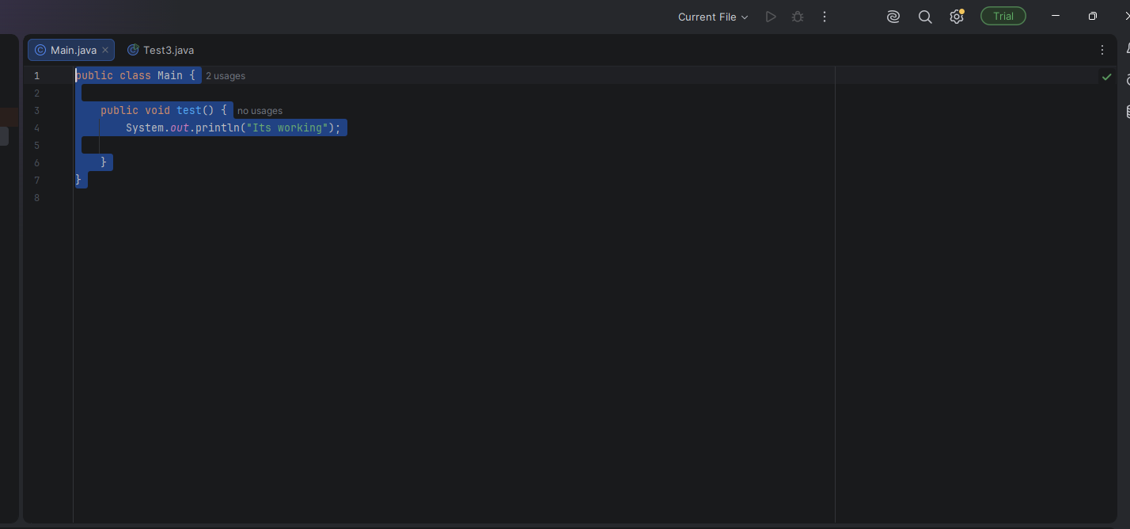

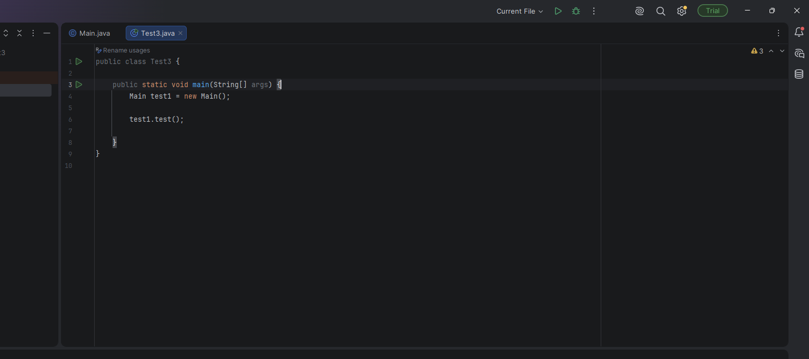

public class Main {
public void test() {
System.out.println("Its working");
}
}

2
public class Test3 {
public static void main(String[] args) {
Main test1 = new Main();
test1.test();
}
}

in more string save and mulitplierer

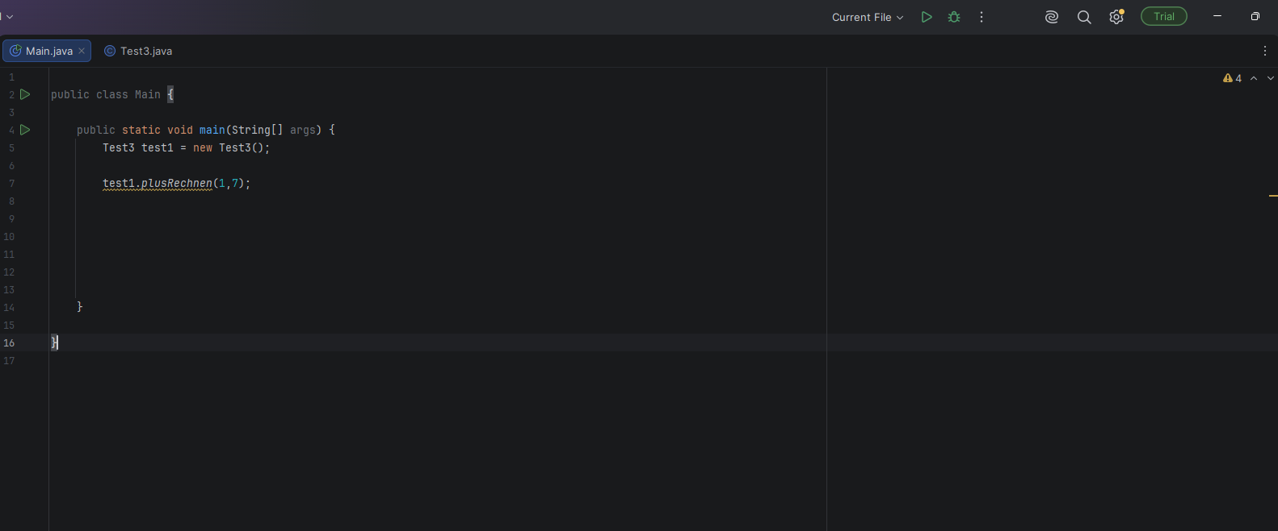

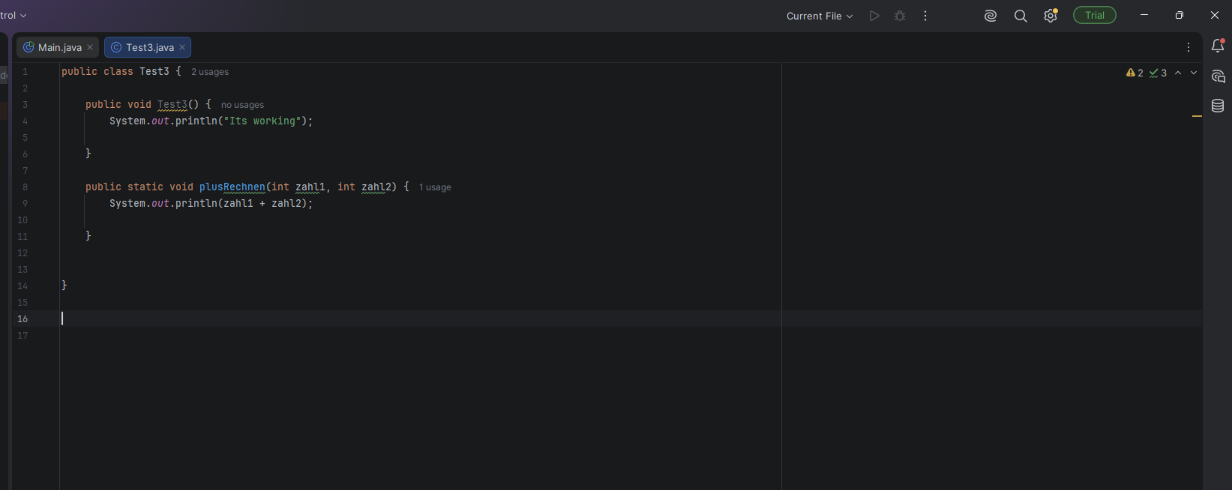

public class Main {
public static void main(String[] args) {
Test3 test1 = new Test3();
test1.plusRechnen(1,7);
}
}

2

public class Test3 {
public void Test3() {
System.out.println("Its working");
}
public static void plusRechnen(int zahl1, int zahl2) {
System.out.println(zahl1 + zahl2);
}
}

Endlosschleife
while(true) {
System.out.println("Hallo");
break; = stoppen
}
Stoppen = Strg + c

} else {
if (money == 5) {
break;
}
Other code
while (true) {
System.out.println("you can buy 800 V-BUCKS for 8.99€. type 1 to buy");
System.out.println("you can buy 2.400 V-BUCKS for 22.99€. type 2 to buy");
System.out.println("type 0 to stop");
int money = scanner.nextInt();
if (money == 0) {
break;
}

Sound in JAVA
Toolkit.getDefaultToolkit().beep();

Fabe in Java

String red = "\u001B[31m";
String green = "\u001B[32m";
String reset = "\u001B[0m";
String blue = "\u001B[34m";

System.out.println("you can buy " + green + 800 + " V-Bucks " + reset + red + " for 8.99€. " + reset + " type " + blue + 1 + reset + " to buy ");

Finish JAVA Fortnite Calculator

import java.util.Scanner;
import java.awt.*;
public class Main {
static int money = 0;
static int vbucks = 0;
static int skins = 0;
static int emotes = 0;
public static void main(String[] args) {
System.out.println("Welcome to Fortnite V-Bugs Calculator.");
String red = "\u001B[31m";
String green = "\u001B[32m";
String reset = "\u001B[0m";
String blue = "\u001B[34m";
while (true) {
Scanner scanner = new Scanner(System.in);
System.out.println("you can buy " + green + 800 + " V-Bucks " + reset + red + " for 8.99€. " + reset + " type " + blue + 1 + reset + " to buy ");
System.out.println("you can buy " + green + 2.400 + " V-BUCKS " + reset + red + " for 22.99€." + reset + " type " + blue + 2 + reset + " to buy");
System.out.println("you can buy" + green + " 4.500 V-Bucks " + reset + red + " for 36.99€. " + reset + " type " + blue + 3 + reset + " to buy ");
System.out.println("You can buy" + green + " 12.500 V-Bugs " + reset + red + " for 89,99€ " + reset + " type " + blue + 4 + reset + " to buy ");
System.out.println(green + "type " + blue + 5 + reset + " to buy skins or Battle Pass " + reset);
System.out.println();
System.out.println("You has " + vbucks + "V-Bucks");
System.out.println();
System.out.println();
//System.out.println("You can buy with 800 V-BUCKS the Battle Pass in fortnite");
Scanner scanner1 = new Scanner(System.in);
Integer money = scanner1.nextInt();
if(money == 1){
Toolkit.getDefaultToolkit().beep();
System.out.println("You has buy " + green + 800 + " V-Bugs " + reset + red + 8.99 + "€" + reset);
System.out.println("You can buy with" + green + 800 + " V-BUCKS " + reset + " the Battle Pass in fortnite");
System.out.println("You can buy with 800 V-BUCKS a Uncommon Skins");
vbucks += 800;
} else {
if (money == 2) {
Toolkit.getDefaultToolkit().beep();
System.out.println("You has buy " + green + 2400 + " V-Bugs " + reset + "for " + 22.99 + "€");
System.out.println("You can buy with " + green + 800 + "V-BUCKS " + reset + " the Battle Pass in fortnite");
System.out.println("You can buy with " + green + 800 + " V-BUCKS " + reset + " a Uncommon Skins");
System.out.println("you can buy with " + green + 1200 + " V-BUCKS " + reset + " a " + " Rare Skins");
vbucks += 2400;
} else {
if (money == 3) {
Toolkit.getDefaultToolkit().beep();
System.out.println("You has buy " + green + 4500 + " V-Bugs " + reset + red + " for " + 36.99 + "€" + reset);
System.out.println("You can buy with " + green + 800 + " V-BUCKS " + reset + " the Battle Pass in fortnite");
System.out.println("You can buy with " + green + 800 + " V-BUCKS " + reset + " a Uncommon Skins");
System.out.println("you can buy with" + green + 1200 + " V-BUCKS " + reset + " a " + " Rare Skins");
System.out.println("You can buy with" + green + 1500 + " V-BUCKS" + reset + " a " + " Epic Skin ");
System.out.println("You can buy with " + green + 2000 + " V-BUCKS " + reset + " Legendary Skin");
vbucks += 4500;
} else {
if (money == 4) {
Toolkit.getDefaultToolkit().beep();
System.out.println("You has buy " + green + 12.500 + " V-Bugs " + reset + red + " for " + 98.99 + "€" + reset);
System.out.println("You can buy with " + green + 800 + " V-BUCKS " + reset + " the Battle Pass in fortnite");
System.out.println("You has buy " + green + 12500 + " V-Bugs " + reset + red + "for " + 89.99 + "€" + reset);
System.out.println("You can buy with " + green + 800 + reset + " V-BUCKS a Uncommon Skins");
System.out.println("you can buy with " + green + 1200 + " V-BUCKS " + reset + " a " + " Rare Skins");
System.out.println("You can buy with " + green + 1500 + " V-BUCKS " + reset + " a " + " Epic Skin ");
System.out.println("You can buy with " + green + 2000 + " V-BUCKS " + reset + " Legendary Skin");
vbucks += 12500;
//System.out.println();
System.out.println();
System.out.println("you has buy " + vbucks + " V-BUCKS");
} else {
if (money == 5) {
break;
}
}
}
}
}
} while (true) {
//System.out.println("test");
System.out.println();
System.out.println("You has " + vbucks + " V-BUCKS " + " left");
System.out.println();
System.out.println("You can buy with " + green + 800 + " V-BUCKS " + reset + " the Battle Pass in fortnite " + " type " + blue + 1 + reset + " to buy the Battle Pass " + "|||" + " You can buy with " + green + 800 + " V-BUCKS " + reset + " a Uncommon Skins" + " type " + blue + 2 + reset + " to buy the " + " the Uncommon Skin");
System.out.println("you can buy with " + green + 1200 + " V-BUCKS " + reset + " a " + " Rare Skins " + " type " + blue + 3 + reset + " to buy the Rare Skin " + "|||" + " You can buy with " + green + 1500 + " V-BUCKS" + reset + " a " + " Epic Skin " + " type " + blue + 4 + reset + " to buy the Epic Skin");
System.out.println("You can buy with " + green + 2000 + " V-BUCKS " + reset + " Legendary Skin" + " type " + blue + 5 + reset + " to buy the Legendary Skin " + "|||" + "You can buy with " + green + 500 + " V-BUCKS " + reset + " a Emote " + " type " + blue + 7 + reset + " to buy the Emote");
System.out.println("You can buy " + green + 800 + " V-BUCKS " + reset + " a Rare Emote " + " type " + blue + 8 + reset + " to buy the Rare Emote");
System.out.println();
System.out.println(green + "Type " + blue + 6 + reset + green + " to exit the Fortnite_V-Bugs_Calculator " + reset);
System.out.println(green + "Type " + blue + 9 + reset + green + " to show your bought Items " + reset);
System.out.println();
Scanner scanner3 = new Scanner(System.in);
Integer scanner2 = scanner3.nextInt();
if(scanner2 == 1 && vbucks >= 800){
Toolkit.getDefaultToolkit().beep();
System.out.println("You has bought " + green + "The Battle Pass in Fortnite" + reset);
vbucks -= 800;
//System.out.println("You has " + vbucks + " V-Bucks" + " left");
} else {
if (scanner2 == 2 && vbucks >= 800) {
Toolkit.getDefaultToolkit().beep();
System.out.println("You has bought " + green + " The uncommon Skin " + reset);
vbucks -= 800;
//System.out.println(" You has " + vbucks + "V-Bucks" + " left");
} else {
if (scanner2 == 3 && vbucks >= 1200) {
Toolkit.getDefaultToolkit().beep();
System.out.println(" You has bought " + green + " Rare Skin " + reset);
vbucks -= 1200;
skins += 1;
//System.out.println("You has " + vbucks + " V-Bucks " + " left");
} else {
if (scanner2 == 4 && vbucks >= 1200) {
Toolkit.getDefaultToolkit().beep();
System.out.println(" You has bought" + green + " Epic Skin " + reset);
vbucks -= 1200;
skins += 1;
//System.out.println("You has " + vbucks + " V-Bucks" + " left");
} else {
if (scanner2 == 5 && vbucks >= 2000) {
Toolkit.getDefaultToolkit().beep();
System.out.println("You has bought" + green + " Epic Skin " + reset);
vbucks -= 2000;
skins += 1;
//System.out.println("You has " + vbucks + " V-Bucks " + " left");
} else {
if (scanner2 == 6 ) {
Toolkit.getDefaultToolkit().beep();
break;
} else {
if (scanner2 == 7 && vbucks >= 500) {
Toolkit.getDefaultToolkit().beep();
System.out.println("You has bought " + green + " Emote " + reset);
vbucks -= 800;
emotes += 1;
} else {
if (scanner2 == 8 && vbucks >= 800) {
Toolkit.getDefaultToolkit().beep();
System.out.println("You has bought " + green + " Rare Emote " + reset);
vbucks -= 800;
emotes += 1;
} else {
if (scanner2 == 9) {
Toolkit.getDefaultToolkit().beep();
System.out.println("You own " + skins + " Skins");
System.out.println("You own " + emotes + " Emotes");
}
}
}
}
}
}
}
}
}
}
}
}

JAVA Commands:
Show the print name Hallo
public class Main {

public static void main(String[] args) {
System.out.println("Hallo");
}
}
Chreate variable

public class Main {

public static void main(String[] args) {
String name = "Junus";
System.out.println("Hallo Welt! ich heiße " + name);
}
}
Chreate variable

public class Main {

public static void main(String[] args) {
String name = "Felix";
String alter = "20";
Integer hour = 11;

System.out.println("Hallo " + name + " du " + " bist " + alter + " alt");
}
}

If (make the code if it’s the right code)

public class Main {

public static void main(String[] args) {
String name = "Felix";
String alter = "20";
String favorite_color = "blue";
Integer hour = 12;
if(hour < 15) {
System.out.println("Welcome roboboy to the Game");
}
}
}

else if the first code is not true then make the other code with else

public class Main {
public static void main(String[] args) {
String name = "Felix";
String alter = "20";
String favorite_color = "blue";
Integer hour = 12;
if(hour < 10) {
System.out.println("Welcome roboboy to the Game");
} else {
System.out.println("Hello world");
}
System.out.println("Hallo " + name + " du " + " bist " + alter + " alt " + " und meine lieblingsfarbe ist " + favorite_color);
}
}

Varieblen

public class Main {

public static void main(String[] args) {
String name = "Felix";
String alter = "20";
String favorite_color = "blue";
Integer hour = 12;

if(hour < 10) {
System.out.println("Good Morning");
} else {
if (hour < 11) {
System.out.println("Good evening");
} else {
System.out.println("goog afternoon");
}
}

}
}

Other public static void

public class Main {

public static void main(String[] args) {
String name = "Felix";
String alter = "20";
String favorite_color = "blue";

sayGreetings();
sayGreetings();

}

public static void sayGreetings() {
Integer hour = 12;

if(hour < 20) {
System.out.println("Good Morning");
} else {
if(hour < 16) {
System.out.println("Good evening");
} else {
System.out.println("goog afternoon");
}
}
}
}
Chage the wert. Make more ways
public class Main {
public static void main(String[] args) {
String name = "Felix";
String alter = "20";
String favorite_color = "blue";
sayGreetings(10);
sayGreetings(20);
}
public static void sayGreetings(Integer hour) {
if(hour < 20) {
System.out.println("Good Morning");
} else {
if(hour < 16) {
System.out.println("Good evening");
} else {
System.out.println("goog afternoon");
}
}
}
}

New Projekt money in doller

public class Main {
public static void main(String[] args) {
Integer euro = 20;
exchangetoeuro(euro);
}
public static void exchangetoeuro(Integer euro) {
System.out.println(euro * 1.20);
}
}

Double cash = 14,5;

Other Projekt
public class Main {
public static void main(String[] args) {
Integer Geld = 20;
exchangetoeuro(Geld);
}
public static void exchangetoeuro(Integer euro) {
System.out.println(euro * 1.20);
}
}

Own Projekt

public class Main {

public static void main(String[] args) {
Integer Geld = 20;

exchangetoeuro(Geld);
bestgame(Geld);
}

public static void exchangetoeuro(Integer euro) {
System.out.println(euro * 1.20);
}

public static void bestgame(Integer euro) {
System.out.println(euro * 200000);
}

}

Exaroton calculator version 1

public class Main {
public static void main(String[] args) {
Integer money = 100;
Integer chose_GB = 1;
Integer hour = 1;
System.out.println("You has buy " + money * 100 + " credits " + " for " + money + "€");
System.out.println("you can play with " + money + "€" + " with " + chose_GB + "GB "+ "for "+ money * 100 / chose_GB + " hours");
}
}

Exaroton calculator version 2 (with input)

import java.util.Scanner;

public class Main {

public static void main(String[] args) {
Integer chose_GB = 5;
Integer hour = 4;
Scanner scanner = new Scanner(System.in);
Integer money = scanner.nextInt();

System.out.println("You has buy " + money * 100 + " credits " + " for " + money + "€");

System.out.println("you can play with " + money + "€" + " with " + chose_GB + "GB "+ "for "+ money * 100 / chose_GB + " hours");
}
}

Exaroton calculator version 3 (with Input and Text)

import java.util.Scanner;

public class Main {

public static void main(String[] args) {
Integer chose_GB = 5;
Integer hour = 4;
System.out.println("Type the money that you want du spent on coins.");
Scanner scanner = new Scanner(System.in);
Integer money = scanner.nextInt();

System.out.println("You has buy " + money * 100 + " credits " + " for " + money + "€");

System.out.println("you can play with " + money + "€" + " with " + chose_GB + "GB "+ "for "+ money * 100 / chose_GB + " hours");
}
}

Exaroton calculator version 4 (with 2 Input and Text)

import java.util.Scanner;

public class Main {

public static void main(String[] args) {
Integer hour = 4;
System.out.println("Type the money that you want du spent on coins.");
Scanner scanner = new Scanner(System.in);
Integer money = scanner.nextInt();

System.out.println("You has buy " + money * 100 + " credits " + " for " + money + "€");

System.out.println("Type down the amount of GB you want to use.");
Scanner scanner2 = new Scanner(System.in);
Integer chose_GB = scanner2.nextInt();

System.out.println("you can play with " + money + "€" + " with " + chose_GB + "GB "+ "for "+ money * 100 / chose_GB + " hours");
}
}

Wert(Variable) = save Variable in Wert
Amount = Amount + 1 = addiet to Amount 1

Chat GPT
import javax.swing.*;
import java.util.Scanner;

public class Main {

public static void main(String[] args) {

System.out.println("Type the money that you want to spend on coins:");

Scanner scanner = new Scanner(System.in);
Integer money = scanner.nextInt();

openUI();

System.out.println(
"You bought "
+ money * 100
+ " credits for "
+ money
+ "€"
);

System.out.println("Type the amount of GB you want to use:");

Integer chose_GB = scanner.nextInt();

System.out.println(
"You can play with "
+ money
+ "€ and "
+ chose_GB
+ "GB for "
+ (money * 100 / chose_GB)
+ " hours"
);

scanner.close();
}

public static void openUI() {

JFrame frame = new JFrame("Exaroton buy coins");

frame.setSize(400, 300);

frame.setLocation(100, 150);

frame.setDefaultCloseOperation(JFrame.EXIT_ON_CLOSE);

frame.setVisible(true);
}
}

With chat GPT and better1
import javax.swing.*;
import java.util.Scanner;

public class Main {

public static void main(String[] args) {

openUI();

System.out.println("Type the money that you want to spend on coins:");

Scanner scanner = new Scanner(System.in);
Integer money = scanner.nextInt();

System.out.println(
"You bought "
+ money * 100
+ " credits for "
+ money
+ "€"
);

System.out.println("Type the amount of GB you want to use:");

Integer chose_GB = scanner.nextInt();

System.out.println(
"You can play with "
+ money
+ "€ and "
+ chose_GB
+ "GB for "
+ (money * 100 / chose_GB)
+ " hours"
);

scanner.close();
}

public static void openUI() {

JFrame frame = new JFrame("Exaroton buy coins");

frame.setSize(400, 300);

frame.setLocation(100, 150);

frame.setDefaultCloseOperation(JFrame.EXIT_ON_CLOSE);

JLabel text = new JLabel("Type the money that you want to spend on coins:");

text.setBounds(50, 50, 200, 30);

frame.add(text);

frame.setVisible(true);
}
}

Own Projekt with 1

import javax.swing.*;
import java.awt.event.ActionEvent;
import java.awt.event.ActionListener;
import java.util.Scanner;
public class Main {
public static void main(String[] args) {
openUI();
System.out.println("Welcome to Exaroton coins Calculator! you can buy 1000 for 10€");
System.out.println("Type the money that you want to spend in Exaroton on coins:");
Scanner scanner = new Scanner(System.in);
Integer money = scanner.nextInt();
System.out.println(
"You bought "
+ money * 100
+ " credits for "
+ money
+ "€"
);
System.out.println("Type the amount of GB you want to use:");
Integer chose_GB = scanner.nextInt();
System.out.println(
"You can play with "
+ money
+ "€ and "
+ chose_GB
+ "GB for "
+ (money * 100 / chose_GB)
+ " hours"
);
scanner.close();
}
public static void openUI() {
JFrame frame = new JFrame("Exaroton buy coins");
frame.setSize(400, 300);
frame.setLocation(100, 150);
frame.setDefaultCloseOperation(JFrame.EXIT_ON_CLOSE);
frame.setDefaultLookAndFeelDecorated(true);
JLabel text = new JLabel("Type the money that you want to spend in Exaroton on coins:");
text.setBounds(50, 50, 200, 30);
JTextField textField = new JTextField();
textField.setBounds(50, 100, 200, 50);
JButton button = new JButton("Buy Coins");
button.setBounds(50, 150, 200, 30);
button.addActionListener(new ActionListener() {
@Override
public void actionPerformed(ActionEvent e) {
String textFromTextfield = textField.getText();
Integer number = Integer.parseInt(textFromTextfield);
money(number);
}
});
frame.add(text);
frame.add(textField);
frame.add(button);
frame.setLayout(null);
frame.setVisible(true);
}
}

Exartoton money to coins calculator with Textfield Java

import javax.swing.*;
import java.awt.event.ActionEvent;
import java.awt.event.ActionListener;
import java.util.Scanner;
public class Main {
public static void main(String[] args) {
openUI();
System.out.println("Welcome to Exaroton coins Calculator! you can buy 1000 for 10€");
System.out.println("Type the money that you want to spend in Exaroton on Coins");
}
public static void money(Integer money) {
System.out.println(
"You bought "
+ money * 100
+ " credits for "
+ money
+ "€"
);
}
public static void openUI() {
JFrame frame = new JFrame("Exaroton buy coins");
frame.setSize(400, 300);
frame.setLocation(100, 150);
frame.setDefaultCloseOperation(JFrame.EXIT_ON_CLOSE);
JLabel text = new JLabel("Type the money that you want to spent on coins:");
text.setBounds(50, 50, 300, 30);
JTextField textField = new JTextField();
textField.setBounds(50, 100, 200, 50);
JButton button = new JButton("Buy Coins");
button.setBounds(50, 150, 200, 30);
button.addActionListener(new ActionListener() {
@Override
public void actionPerformed(ActionEvent e) {
String textFromTextfield = textField.getText();
Integer number = Integer.parseInt(textFromTextfield);
money(number);
text.setText("You bought " + number * 100 + " credits for " + number + "€");
}
});
frame.add(text);
frame.add(textField);
frame.add(button);
frame.setLayout(null);
frame.setVisible(true);
}
}

Exartoton money to coins calculator with cmd

import java.util.Scanner;

public class Main {

public static void main(String[] args) {
Integer hour = 4;
System.out.println("Welcome to Exaroton Calculator.");

System.out.println("You can buy on the Website with PayPal, Card and PaysafeCard.");

System.out.println("Type the money that you want du spent on coins.");

Scanner scanner = new Scanner(System.in);
Integer money = scanner.nextInt();

System.out.println("You has buy " + money * 100 + " credits " + " for " + money + "€");

System.out.println("Type down the amount of GB you want to use.");
Scanner scanner2 = new Scanner(System.in);
Integer chose_GB = scanner2.nextInt();

System.out.println("you can play with " + money + "€" + " with " + chose_GB + "GB "+ "for "+ money * 100 / chose_GB + " hours.");
}
}

Fortnite V-Bugs calculator

import java.util.Scanner;
public class Main {
public static void main(String[] args) {
System.out.println("Welcome to Fortnite V-Bugs Calculator.");
Scanner scanner = new Scanner(System.in);
System.out.println("you can buy 800 V-BUCKS for 8.99€. type 1 to buy");
System.out.println("you can buy 2.400 V-BUCKS for 22.99€. type 2 to buy");
System.out.println("you can buy 4.500 V-Bucks for 36.99€. type 3 to buy");
System.out.println("You can buy 12.500 V-Bugs for 89,99€ type 4 to buy");
System.out.println();
//System.out.println("You can buy with 800 V-BUCKS the Battle Pass in fortnite");
Scanner scanner1 = new Scanner(System.in);
Integer money = scanner1.nextInt();
if(money == 1){
System.out.println("You has buy " + 800 + " V-Bugs " + " for " + 8.99 + "€");
System.out.println("You can buy with 800 V-BUCKS the Battle Pass in fortnite");
System.out.println("You can buy with 800 V-BUCKS a Uncommon Skins");
} else {
if(money == 2){
System.out.println("You has buy " + 2400 + " V-Bugs " + "for " + 22.99 + "€");
System.out.println("You can buy with 800 V-BUCKS the Battle Pass in fortnite");
System.out.println("You can buy with 800 V-BUCKS a Uncommon Skins");
System.out.println("you can buy with" + 1200 + " V-BUCKS " + " a " + " Rare Skins");
} else {
if(money == 3){
System.out.println("You has buy " + 4500 + " V-Bugs " + " for " + 36.99 + "€");
System.out.println("You can buy with 800 V-BUCKS the Battle Pass in fortnite");
System.out.println("You can buy with 800 V-BUCKS a Uncommon Skins");
System.out.println("you can buy with" + 1200 + " V-BUCKS " + " a " + " Rare Skins");
System.out.println("You can buy with" + 1500 + " V-BUCKS" + " a " + " Epic Skin ");
System.out.println("You can buy with " + 2000 + " V-BUCKS " + " Legendary Skin");
} else {
if(money == 4){
System.out.println("You can buy with 800 V-BUCKS the Battle Pass in fortnite");
System.out.println("You has buy " + 12500 + " V-Bugs " + "for " + 89.99 + "€");
System.out.println("You can buy with 800 V-BUCKS a Uncommon Skins");
System.out.println("you can buy with" + 1200 + " V-BUCKS " + " a " + " Rare Skins");
System.out.println("You can buy with" + 1500 + " V-BUCKS" + " a " + " Epic Skin ");
System.out.println("You can buy with " + 2000 + " V-BUCKS " + " Legendary Skin");
}
}
}
}
//System.out.println("You has buy" + money * 100 + "V-Bugs for" + money + "€");
}
}

Fortnite calculator version 1

import java.util.Scanner;
public class Main {
public static void main(String[] args) {
System.out.println("Welcome to Fortnite V-Bugs Calculator.");
Scanner scanner = new Scanner(System.in);
System.out.println("you can buy 800 V-BUCKS for 8.99€. type 1 to buy");
System.out.println("you can buy 2.400 V-BUCKS for 22.99€. type 2 to buy");
System.out.println("you can buy 4.500 V-Bucks for 36.99€. type 3 to buy");
System.out.println("You can buy 12.500 V-Bugs for 89,99€ type 4 to buy");
System.out.println();
//System.out.println("You can buy with 800 V-BUCKS the Battle Pass in fortnite");
int vbucks = 0;
Scanner scanner1 = new Scanner(System.in);
Integer money = scanner1.nextInt();
if(money == 1){
System.out.println("You has buy " + 800 + " V-Bugs " + " for " + 8.99 + "€");
System.out.println("You can buy with 800 V-BUCKS the Battle Pass in fortnite");
System.out.println("You can buy with 800 V-BUCKS a Uncommon Skins");
vbucks += 800;
} else {
if(money == 2){
System.out.println("You has buy " + 2400 + " V-Bugs " + "for " + 22.99 + "€");
System.out.println("You can buy with 800 V-BUCKS the Battle Pass in fortnite");
System.out.println("You can buy with 800 V-BUCKS a Uncommon Skins");
System.out.println("you can buy with" + 1200 + " V-BUCKS " + " a " + " Rare Skins");
vbucks += 2400;
} else {
if(money == 3){
System.out.println("You has buy " + 4500 + " V-Bugs " + " for " + 36.99 + "€");
System.out.println("You can buy with 800 V-BUCKS the Battle Pass in fortnite");
System.out.println("You can buy with 800 V-BUCKS a Uncommon Skins");
System.out.println("you can buy with" + 1200 + " V-BUCKS " + " a " + " Rare Skins");
System.out.println("You can buy with" + 1500 + " V-BUCKS" + " a " + " Epic Skin ");
System.out.println("You can buy with " + 2000 + " V-BUCKS " + " Legendary Skin");
vbucks += 300;
} else {
if(money == 4){
System.out.println("You has buy " + 12.500 + " V-Bugy " + " for " + 98.99 + "€");
System.out.println("You can buy with 800 V-BUCKS the Battle Pass in fortnite");
System.out.println("You has buy " + 12500 + " V-Bugs " + "for " + 89.99 + "€");
System.out.println("You can buy with 800 V-BUCKS a Uncommon Skins");
System.out.println("you can buy with" + 1200 + " V-BUCKS " + " a " + " Rare Skins");
System.out.println("You can buy with" + 1500 + " V-BUCKS" + " a " + " Epic Skin ");
System.out.println("You can buy with " + 2000 + " V-BUCKS " + " Legendary Skin");
vbucks += 12500;
//System.out.println();
System.out.println();
System.out.println("you has buy " + vbucks + " V-BUCKS");
}
}
}
}
//System.out.println("test");
System.out.println();
System.out.println("You has bought " + vbucks + " V-BUCKS");
}
}

if(money == 1 && vbucks == 800){
System.out.println("Correct!");

111111111111Fortnite V-Bucks calculator
import java.util.Scanner;
public class Main {
public static void main(String[] args) {
System.out.println("Welcome to Fortnite V-Bugs Calculator.");
Scanner scanner = new Scanner(System.in);
System.out.println("you can buy 800 V-BUCKS for 8.99€. type 1 to buy");
System.out.println("you can buy 2.400 V-BUCKS for 22.99€. type 2 to buy");
System.out.println("you can buy 4.500 V-Bucks for 36.99€. type 3 to buy");
System.out.println("You can buy 12.500 V-Bugs for 89,99€ type 4 to buy");
System.out.println();
//System.out.println("You can buy with 800 V-BUCKS the Battle Pass in fortnite");
int vbucks = 0;
Scanner scanner1 = new Scanner(System.in);
Integer money = scanner1.nextInt();
if(money == 1){
System.out.println("You has buy " + 800 + " V-Bugs " + " for " + 8.99 + "€");
System.out.println("You can buy with 800 V-BUCKS the Battle Pass in fortnite");
System.out.println("You can buy with 800 V-BUCKS a Uncommon Skins");
vbucks += 800;
} else {
if(money == 2){
System.out.println("You has buy " + 2400 + " V-Bugs " + "for " + 22.99 + "€");
System.out.println("You can buy with 800 V-BUCKS the Battle Pass in fortnite");
System.out.println("You can buy with 800 V-BUCKS a Uncommon Skins");
System.out.println("you can buy with" + 1200 + " V-BUCKS " + " a " + " Rare Skins");
vbucks += 2400;
} else {
if(money == 3){
System.out.println("You has buy " + 4500 + " V-Bugs " + " for " + 36.99 + "€");
System.out.println("You can buy with 800 V-BUCKS the Battle Pass in fortnite");
System.out.println("You can buy with 800 V-BUCKS a Uncommon Skins");
System.out.println("you can buy with" + 1200 + " V-BUCKS " + " a " + " Rare Skins");
System.out.println("You can buy with" + 1500 + " V-BUCKS" + " a " + " Epic Skin ");
System.out.println("You can buy with " + 2000 + " V-BUCKS " + " Legendary Skin");
vbucks += 300;
} else {
if(money == 4){
System.out.println("You has buy " + 12.500 + " V-Bugy " + " for " + 98.99 + "€");
System.out.println("You can buy with 800 V-BUCKS the Battle Pass in fortnite");
System.out.println("You has buy " + 12500 + " V-Bugs " + "for " + 89.99 + "€");
System.out.println("You can buy with 800 V-BUCKS a Uncommon Skins");
System.out.println("you can buy with" + 1200 + " V-BUCKS " + " a " + " Rare Skins");
System.out.println("You can buy with" + 1500 + " V-BUCKS" + " a " + " Epic Skin ");
System.out.println("You can buy with " + 2000 + " V-BUCKS " + " Legendary Skin");
vbucks += 12500;
//System.out.println();
System.out.println();
System.out.println("you has buy " + vbucks + " V-BUCKS");
}
}
}
}
//System.out.println("test");
System.out.println();
System.out.println("You has bought " + vbucks + " V-BUCKS");
System.out.println();
System.out.println("You can buy with 800 V-BUCKS the Battle Pass in fortnite " + " type 1 to buy the Battle Pass");
System.out.println("You can buy with 800 V-BUCKS a Uncommon Skins" + " type 2 to buy the " + " the Uncommon Skin");
System.out.println("you can buy with" + 1200 + " V-BUCKS " + " a " + " Rare Skins" + "type 3 to buy the Rare Skin");
System.out.println("You can buy with" + 1500 + " V-BUCKS" + " a " + " Epic Skin " + "type 4 to buy the Epic Skin");
System.out.println("You can buy with " + 2000 + " V-BUCKS " + " Legendary Skin" + "type 5 to buy the Legendary Skin");
Scanner scanner3 = new Scanner(System.in);
Integer scanner2 = scanner3.nextInt();
if(scanner2 == 1 && vbucks >= 800){
System.out.println("You has bought " + "The Battle Pass in Fortnite");
vbucks -= 800;
System.out.println("You has " + vbucks + " V-Bucks" + " left");
} else {
if(scanner2 == 2 && vbucks >= 800){
System.out.println("You has bought " + " The uncommon Skin ");
vbucks -= 800;
System.out.println(" You has " + vbucks + "V-Bucks" + " left");
} else {
if(scanner2 == 3 && vbucks >= 1200){
System.out.println(" You has bought " + " Rare Skin");
vbucks -= 1200;
System.out.println("You has " + vbucks + " V-Bucks " + " left");
} else {
if(scanner2 == 4 && vbucks >= 1200){
System.out.println(" You has bought" + " Epic Skin");
vbucks -= 1200;
System.out.println("You has " + vbucks + " V-Bucks" + " left");
} else {
if(scanner2 == 5 && vbucks >= 2000){
System.out.println("You has bought" + " Epic Skin");
vbucks -= 2000;
System.out.println("You has " + vbucks + " V-Bucks " + " left");
}
}
}
}
}
}
}

Fortinte calculator v. 2

import java.util.Scanner;
public class Main {
static int money = 0;
static int vbucks = 0;
public static void main(String[] args) {
System.out.println("Welcome to Fortnite V-Bugs Calculator.");
String red = "\u001B[31m";
String green = "\u001B[32m";
String reset = "\u001B[0m";
while (true) {
Scanner scanner = new Scanner(System.in);
System.out.println("you can buy " + green + 800 + " V-Bucks " + reset + red + "for 8.99€." + reset + "type 1 to buy");
System.out.println("you can buy " + green + 2.400 + " V-BUCKS " + reset + red + " for 22.99€." + reset + "type 2 to buy");
System.out.println("you can buy" + green + "4.500 V-Bucks" + reset + red + "for 36.99€." + reset + "type 3 to buy");
System.out.println("You can buy 12.500 V-Bugs for 89,99€ type 4 to buy");
System.out.println("type 5 to buy skins or Battle Pass");
System.out.println();
System.out.println("You has " + vbucks + "V-Bucks");
System.out.println();
System.out.println();
//System.out.println("You can buy with 800 V-BUCKS the Battle Pass in fortnite");
Scanner scanner1 = new Scanner(System.in);
Integer money = scanner1.nextInt();
if(money == 1){
System.out.println("You has buy " + 800 + " V-Bugs " + " for " + 8.99 + "€");
System.out.println("You can buy with 800 V-BUCKS the Battle Pass in fortnite");
System.out.println("You can buy with 800 V-BUCKS a Uncommon Skins");
vbucks =+ 800;
} else {
if (money == 2) {
System.out.println("You has buy " + 2400 + " V-Bugs " + "for " + 22.99 + "€");
System.out.println("You can buy with 800 V-BUCKS the Battle Pass in fortnite");
System.out.println("You can buy with 800 V-BUCKS a Uncommon Skins");
System.out.println("you can buy with" + 1200 + " V-BUCKS " + " a " + " Rare Skins");
vbucks += 2400;
} else {
if (money == 3) {
System.out.println("You has buy " + 4500 + " V-Bugs " + " for " + 36.99 + "€");
System.out.println("You can buy with 800 V-BUCKS the Battle Pass in fortnite");
System.out.println("You can buy with 800 V-BUCKS a Uncommon Skins");
System.out.println("you can buy with" + 1200 + " V-BUCKS " + " a " + " Rare Skins");
System.out.println("You can buy with" + 1500 + " V-BUCKS" + " a " + " Epic Skin ");
System.out.println("You can buy with " + 2000 + " V-BUCKS " + " Legendary Skin");
vbucks += 4500;
} else {
if (money == 4) {
System.out.println("You has buy " + 12.500 + " V-Bugy " + " for " + 98.99 + "€");
System.out.println("You can buy with 800 V-BUCKS the Battle Pass in fortnite");
System.out.println("You has buy " + 12500 + " V-Bugs " + "for " + 89.99 + "€");
System.out.println("You can buy with 800 V-BUCKS a Uncommon Skins");
System.out.println("you can buy with" + 1200 + " V-BUCKS " + " a " + " Rare Skins");
System.out.println("You can buy with" + 1500 + " V-BUCKS" + " a " + " Epic Skin ");
System.out.println("You can buy with " + 2000 + " V-BUCKS " + " Legendary Skin");
vbucks += 12500;
//System.out.println();
System.out.println();
System.out.println("you has buy " + vbucks + " V-BUCKS");
} else {
if (money == 5) {
break;
}
}
}
}
}
} while (true) {
//System.out.println("test");
System.out.println();
System.out.println("You has bought " + vbucks + " V-BUCKS");
System.out.println();
System.out.println("You can buy with 800 V-BUCKS the Battle Pass in fortnite " + " type 1 to buy the Battle Pass");
System.out.println("You can buy with 800 V-BUCKS a Uncommon Skins" + " type 2 to buy the " + " the Uncommon Skin");
System.out.println("you can buy with " + 1200 + " V-BUCKS " + " a " + " Rare Skins" + "type 3 to buy the Rare Skin");
System.out.println("You can buy with " + 1500 + " V-BUCKS" + " a " + " Epic Skin " + "type 4 to buy the Epic Skin");
System.out.println("You can buy with " + 2000 + " V-BUCKS " + " Legendary Skin" + "type 5 to buy the Legendary Skin");
System.out.println("Type 6 to exit the Fortnite_V-Bugs_Calculator ");
Scanner scanner3 = new Scanner(System.in);
Integer scanner2 = scanner3.nextInt();
if(scanner2 == 1 && vbucks >= 800){
System.out.println("You has bought " + "The Battle Pass in Fortnite");
vbucks -= 800;
System.out.println("You has " + vbucks + " V-Bucks" + " left");
} else {
if (scanner2 == 2 && vbucks >= 800) {
System.out.println("You has bought " + " The uncommon Skin ");
vbucks -= 800;
System.out.println(" You has " + vbucks + "V-Bucks" + " left");
} else {
if (scanner2 == 3 && vbucks >= 1200) {
System.out.println(" You has bought " + " Rare Skin");
vbucks -= 1200;
System.out.println("You has " + vbucks + " V-Bucks " + " left");
} else {
if (scanner2 == 4 && vbucks >= 1200) {
System.out.println(" You has bought" + " Epic Skin");
vbucks -= 1200;
System.out.println("You has " + vbucks + " V-Bucks" + " left");
} else {
if (scanner2 == 5 && vbucks >= 2000) {
System.out.println("You has bought" + " Epic Skin");
vbucks -= 2000;
System.out.println("You has " + vbucks + " V-Bucks " + " left");
} else {
if (scanner2 == 6 ) {
break;
}
}
}
}
}
}
}
}
}

Fortntie calculator with color

import java.util.Scanner;
public class Main {
static int money = 0;
static int vbucks = 0;
public static void main(String[] args) {
System.out.println("Welcome to Fortnite V-Bugs Calculator.");
String red = "\u001B[31m";
String green = "\u001B[32m";
String reset = "\u001B[0m";
while (true) {
Scanner scanner = new Scanner(System.in);
System.out.println("you can buy " + green + 800 + " V-Bucks " + reset + red + " for 8.99€. " + reset + "type 1 to buy");
System.out.println("you can buy " + green + 2.400 + " V-BUCKS " + reset + red + " for 22.99€." + reset + "type 2 to buy");
System.out.println("you can buy" + green + " 4.500 V-Bucks " + reset + red + " for 36.99€. " + reset + "type 3 to buy");
System.out.println("You can buy" + green + " 12.500 V-Bugs " + reset + red + " for 89,99€ " + reset + "type 4 to buy");
System.out.println(green + "type 5 to buy skins or Battle Pass " + reset);
System.out.println();
System.out.println("You has " + vbucks + "V-Bucks");
System.out.println();
System.out.println();
//System.out.println("You can buy with 800 V-BUCKS the Battle Pass in fortnite");
Scanner scanner1 = new Scanner(System.in);
Integer money = scanner1.nextInt();
if(money == 1){
System.out.println("You has buy " + green + 800 + " V-Bugs " + reset + red + 8.99 + "€" + reset);
System.out.println("You can buy with" + green + 800 + " V-BUCKS " + reset + " the Battle Pass in fortnite");
System.out.println("You can buy with 800 V-BUCKS a Uncommon Skins");
vbucks =+ 800;
} else {
if (money == 2) {
System.out.println("You has buy " + green + 2400 + " V-Bugs " + reset + "for " + 22.99 + "€");
System.out.println("You can buy with " + green + 800 + "V-BUCKS " + reset + " the Battle Pass in fortnite");
System.out.println("You can buy with " + green + 800 + " V-BUCKS " + reset + " a Uncommon Skins");
System.out.println("you can buy with " + green + 1200 + " V-BUCKS " + reset + " a " + " Rare Skins");
vbucks += 2400;
} else {
if (money == 3) {
System.out.println("You has buy " + green + 4500 + " V-Bugs " + reset + red + " for " + 36.99 + "€" + reset);
System.out.println("You can buy with " + green + 800 + " V-BUCKS " + reset + " the Battle Pass in fortnite");
System.out.println("You can buy with " + green + 800 + " V-BUCKS " + reset + " a Uncommon Skins");
System.out.println("you can buy with" + green + 1200 + " V-BUCKS " + reset + " a " + " Rare Skins");
System.out.println("You can buy with" + green + 1500 + " V-BUCKS" + reset + " a " + " Epic Skin ");
System.out.println("You can buy with " + green + 2000 + " V-BUCKS " + reset + " Legendary Skin");
vbucks += 4500;
} else {
if (money == 4) {
System.out.println("You has buy " + green + 12.500 + " V-Bugs " + reset + red + " for " + 98.99 + "€" + reset);
System.out.println("You can buy with " + green + 800 + " V-BUCKS " + reset + " the Battle Pass in fortnite");
System.out.println("You has buy " + green + 12500 + " V-Bugs " + reset + red + "for " + 89.99 + "€" + reset);
System.out.println("You can buy with " + green + 800 + reset + " V-BUCKS a Uncommon Skins");
System.out.println("you can buy with " + green + 1200 + " V-BUCKS " + reset + " a " + " Rare Skins");
System.out.println("You can buy with " + green + 1500 + " V-BUCKS " + reset + " a " + " Epic Skin ");
System.out.println("You can buy with " + green + 2000 + " V-BUCKS " + reset + " Legendary Skin");
vbucks += 12500;
//System.out.println();
System.out.println();
System.out.println("you has buy " + vbucks + " V-BUCKS");
} else {
if (money == 5) {
break;
}
}
}
}
}
} while (true) {
//System.out.println("test");
System.out.println();
System.out.println("You has " + vbucks + " V-BUCKS " + " left");
System.out.println();
System.out.println("You can buy with " + green + 800 + " V-BUCKS " + reset + " the Battle Pass in fortnite " + " type 1 to buy the Battle Pass");
System.out.println("You can buy with " + green + 800 + " V-BUCKS " + reset + " a Uncommon Skins" + " type 2 to buy the " + " the Uncommon Skin");
System.out.println("you can buy with " + green + 1200 + " V-BUCKS " + reset + " a " + " Rare Skins " + "type 3 to buy the Rare Skin");
System.out.println("You can buy with " + green + 1500 + " V-BUCKS" + reset + " a " + " Epic Skin " + "type 4 to buy the Epic Skin");
System.out.println("You can buy with " + green + 2000 + " V-BUCKS " + reset + " Legendary Skin" + "type 5 to buy the Legendary Skin");
System.out.println(green + "Type 6 to exit the Fortnite_V-Bugs_Calculator " + reset);
Scanner scanner3 = new Scanner(System.in);
Integer scanner2 = scanner3.nextInt();
if(scanner2 == 1 && vbucks >= 800){
System.out.println("You has bought " + "The Battle Pass in Fortnite");
vbucks -= 800;
//System.out.println("You has " + vbucks + " V-Bucks" + " left");
} else {
if (scanner2 == 2 && vbucks >= 800) {
System.out.println("You has bought " + " The uncommon Skin ");
vbucks -= 800;
//System.out.println(" You has " + vbucks + "V-Bucks" + " left");
} else {
if (scanner2 == 3 && vbucks >= 1200) {
System.out.println(" You has bought " + " Rare Skin");
vbucks -= 1200;
//System.out.println("You has " + vbucks + " V-Bucks " + " left");
} else {
if (scanner2 == 4 && vbucks >= 1200) {
System.out.println(" You has bought" + " Epic Skin");
vbucks -= 1200;
//System.out.println("You has " + vbucks + " V-Bucks" + " left");
} else {
if (scanner2 == 5 && vbucks >= 2000) {
System.out.println("You has bought" + " Epic Skin");
vbucks -= 2000;
//System.out.println("You has " + vbucks + " V-Bucks " + " left");
} else {
if (scanner2 == 6 ) {
break;
}
}
}
}
}
}
}
}
}

scanner

import java.util.Scanner;
public class Main {
public static void main(String[] args) {
Scanner scantest = new Scanner(System.in);
String sentence;
int savetest;
savetest = scantest.nextInt();
System.out.println(savetest);
}
}

